WORKSHOP PROJECT

SMART HOUSE

- Title of the Project: Smart House

- Objective:

To make life more comfortable by integrating the household appliances with internet.

- Tools used:

Arduino UNO, 12 V DC Motor, IC L293D Motor Driver, Bluetooth module HC-05, LEDs, Jumper wires, Breadboard, Soldering iron, Hot glue gun, resistors, Cardboard and Acrylic sheets etc.

Description:

- Arduino UNO:

The Arduino UNO is an open-source microcontroller board based on the Microchip ATmega320P microcontroller and developed by Arduino.cc. The board is equipped with sets of digital and analog input/output (I/O) pins that may be interfaced to various expansion boards (shields) and other circuits. The board has 14 Digital pins, 6 Analog pins, and programmable with the Arduino IDE(Integrated Development Environment) via a type B USB cable. It can be powered by a USB cable or by an external 9 volt battery, though it accepts voltages between 7 and 20 volts. The Uno board and version 1.0 of Arduino Software (IDE) were the reference versions of Arduino, now evolved to newer releases. The Uno board is the first in a series of USB Arduino boards, and the reference model for the Arduino platform.

2. DC Motor:

A DC Motor is any of a class of rotary electrical machines that converts direct current electrical energy into mechanical energy. The most common types rely on the forces produced by magnetic fields. Nearly all types of DC motors have some internal mechanism, either electromechanical or electronic, to periodically change the direction of current flow in part of the motor.

- 3. IC L293D Motor Driver:

L293D is a typical Motor driver or Motor Driver IC which allows DC motor to drive on either direction. L293D is a 16-pin IC which can control a set of two DC motors simultaneously in any direction. It means that you can control two DC motor with a single L293D IC. In a single L293D chip there are two h-Bridge circuit inside the IC which can rotate two DC motor independently. H-bridge is a circuit which allows the voltage to be flown in either direction. H-bridge IC are ideal for driving a DC motor. Due its size it is very much used in robotic application for controlling DC motors.

4. Bluetooth module HC-05:

HC-05 module is an easy to use Bluetooth SPP (Serial Port Protocol) module, designed for transparent wireless serial connection setup. Serial port Bluetooth module is fully qualified Bluetooth V2.0+EDR (Enhanced Data Rate) 3Mbps Modulation with complete 2.4GHz radio transceiver and baseband. It uses CSR Bluecore 04-External single chip Bluetooth system with CMOS technology and with AFH(Adaptive Frequency Hopping Feature). It has the footprint as small as 12.7mmx27mm.

Difficulties faced:

- 1. Operation of DC Motor using bluetooth module and arduino .

Writing the code for operating the motor using the IC L293D.Initially the motor was not operating as required. Then after referring to the internet the problem was fixed.

2. Coding in Arduino UNO

Getting familiarized to the new language took time. Also understanding the new commands was difficult.

3. Developing the App using MIT app inventor.

Getting familiarized to tools and design features provided in the website.

4. Connections of circuits and assembling it inside the model.

Descriptions and Solutions

1. The code for the motor driver was written ,after referring to the internet .the connections were made according to the attached circuit diagram ,modified to work for a single motor.

2. The code in arduino was written in such a way that when a character input from the Bluetooth module is received, it is compared to preset values for each of the appliance(in sync with the app developed).

3. While developing the app, basically two parts had to be designed , that is the blocks part and the designer part. In the designer part,we had to design the screen features and layout for each screen separately. The blocks part is where commands are given for the selection of each component present on the screen.

4. The connection had to be made rigidly so that they do not get detached easily. They also had to brought along the walls of the house to the breadboard .

Individual Contributions

Arduino Coding -Rahul Jiji George(16.66%),Amjith A Shaheer(16.66%)

App Development- Jayant Suresh(16.66%),Abin Selby(16.66%)

Circuit Connections - Rajath R(16.66%),Abijith R(16.66%)

Conclusion

The smart house was successfully completed in time , the app links successfully with the Bluetooth module and the efficient output was obtained for all the appliances. The system can be extended to operate real life high voltage appliances using relay circuits.

Even-though we faced difficulties at some phases of the project with coordination of team members ,we could find the solution to every problem, within the time allotted.

ARDUINO code used in the project:

// *** CODE FOR SMART HOUSE***
//
//
//
int op=1 ,cl=0;
int motorpin1 = 3; //connected to the motor
int motorpin2 = 6; //connected to the motor
int acled =12; //led to indicate the circuit to the AC
int heaterled= 7; //led to ndicate the circuit to the heater
int lights =10; //controls for the lights of the room
void setup()
{
// put your setup code here, to run once:
Serial.begin(9600);
pinMode(motorpin1,OUTPUT); //setting the output and input pins
pinMode(motorpin2,OUTPUT);
pinMode(acled,OUTPUT);
pinMode(heaterled,OUTPUT);
pinMode(lights,OUTPUT);

}

void loop()
{
// put your main code here, to run repeatedly:
if(Serial.available()>0)
{
char data;
data=Serial.read();
Serial.println(data);
if(data=='c') {
digitalWrite(acled,HIGH);
delay(1000);
}//for the ac
else if(data=='d')
{
digitalWrite(acled,LOW);
delay(1000);
}
else if(data=='e')
{
digitalWrite(heaterled,HIGH);
delay(1000);
}
//for the heater

else if(data=='f')
{
digitalWrite(heaterled,LOW);
delay(1000);
}

else if(data=='a' && op==1) //for opening of garage
{
digitalWrite(motorpin1, HIGH);
digitalWrite(motorpin2, LOW);
delay(250);
op=0;
cl=1;
digitalWrite(motorpin1, LOW);
digitalWrite(motorpin2, LOW);
}
else if(data=='b' && cl==1)//for closing the garage
{
digitalWrite(motorpin1, LOW);
digitalWrite(motorpin2, HIGH);
delay(250);
cl=0;
op=1;
digitalWrite(motorpin1, LOW);
digitalWrite(motorpin2, LOW);
}
else if(data=='g')
{
digitalWrite(lights,HIGH);
delay(1000);
}//for the room lights

else if(data=='h')
{
digitalWrite(lights,LOW);
delay(1000);
}

}

}

Some stages involved in app development:
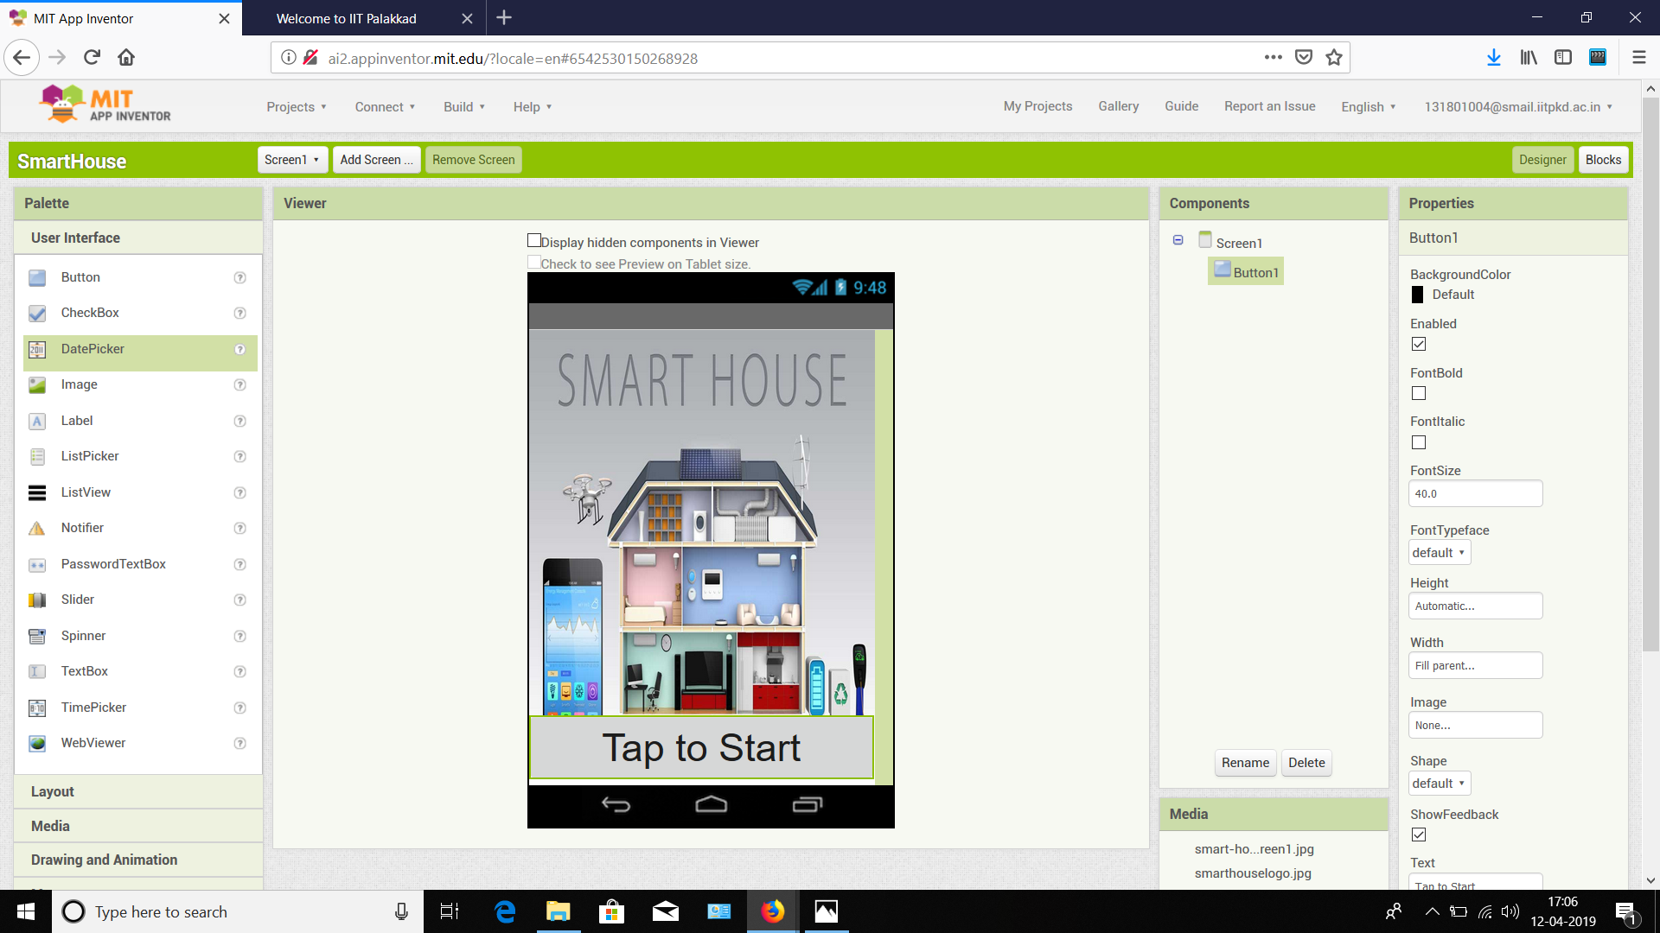
Fig: Designer for start screen of app

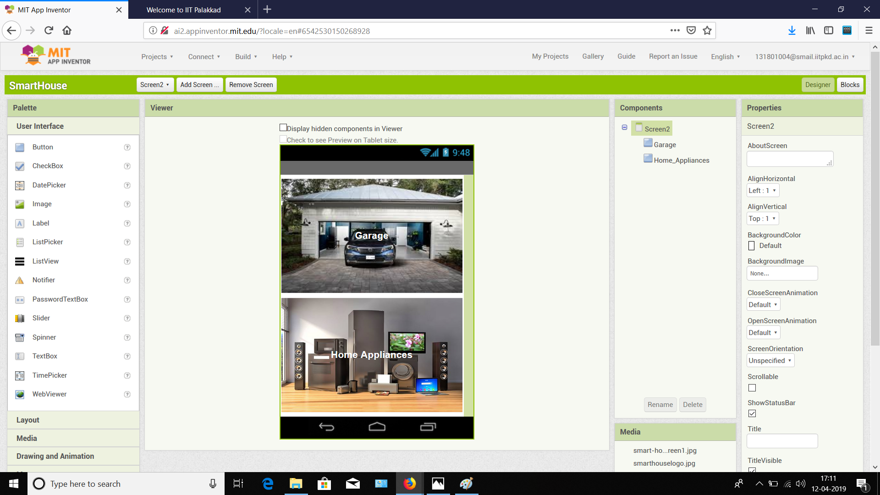
Fig: Designer of Garage/Home Appliances select screen

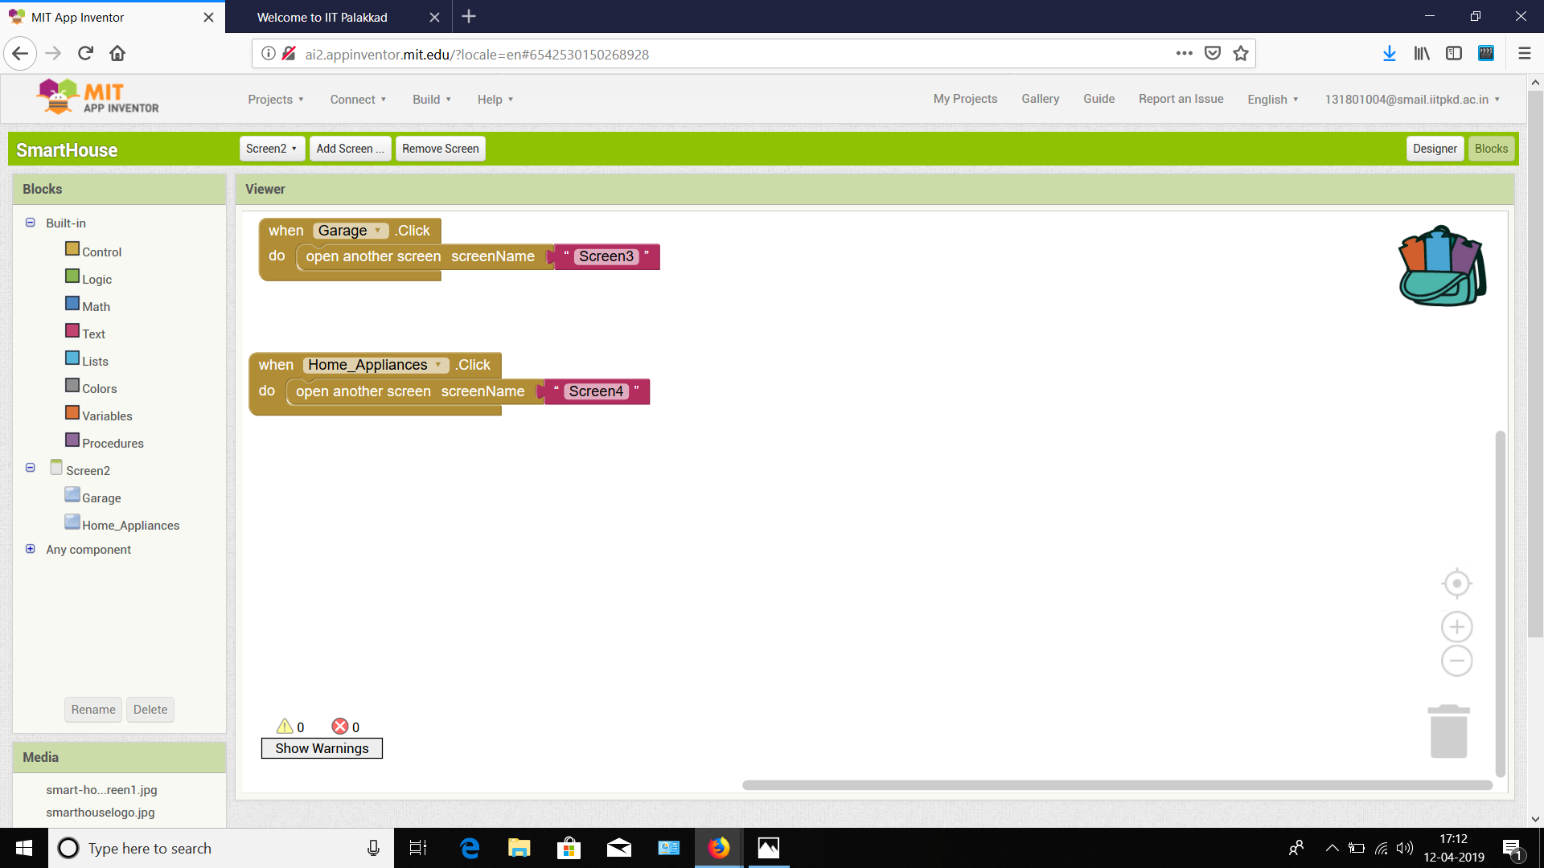
Fig: Blocks of Garage/Home Appliances select screen.
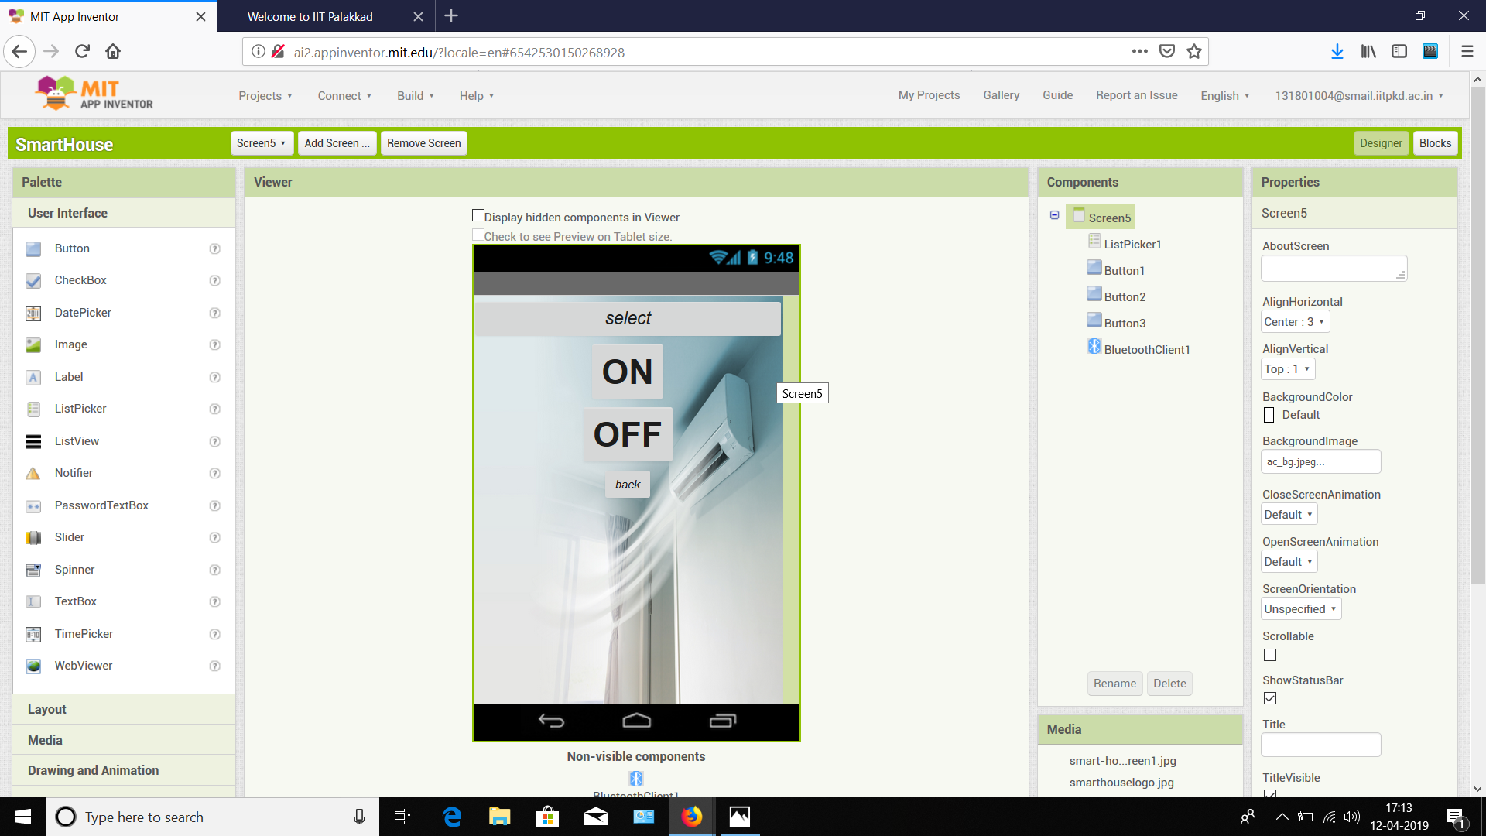
Fig: Designer for AC On/OFF screen

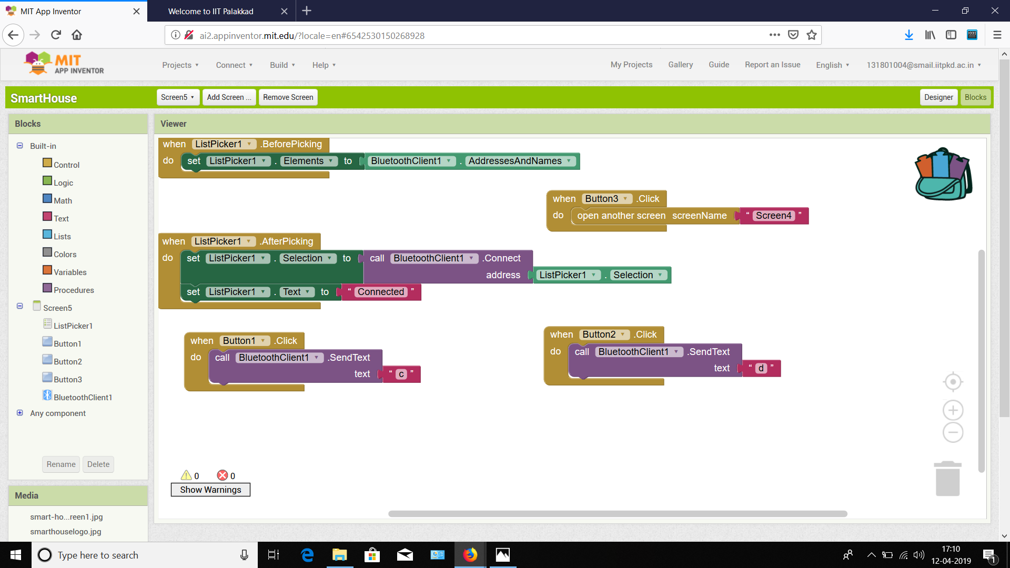
Fig: Blocks AC On/OFF screen

Circuit Diagram:
